Kathmandu University

**Department of Computer Science and Engineering**

**Dhulikhel, Kavre**



**A Project Report**

**on**

**“COVID Update”**

**[Course Code: COMP 313]**

**(For partial fulfillment of III Year/ II Semester in Computer**

**Science)**

**Submitted By**

Hrishav Raghu Shrestha (73)

Shubh Raj Dhital(70)

Rikesh Karmacharya(62)

**Submitted To**

Department of Computer Science and Engineering

**Submission Date**

28th September, 2020

**Bonafide Certificate**

**This project work on**

**“COVID Update”**

**is the bonafide work of**

**“***Hrishav Raghu Shrestha*

*Shubh Raj Dhital*

*Rikesh Karmacharya***”**

**Who carried out the project work under my supervision.**

**Project Supervisor**

**_____________________**

**Name: Mr. Satyendra Lohani**

**Lecturer , DOCSE, KU**

# Acknowledgement

The preparation of our project ‘COVID Update’ was made possible through the valuable contribution of ‘Department of Computer Science and Engineering’ and our project coordinator **Dr. Gajendra Sharma** as well as our supervisor **Mr. Satyendra Lohani** who gave us platform to work away from our regular course and gave his precious time to involve and discuss about the necessary parts for the development of our project. His help in maintaining a sequential execution of tasks helped us meet all the deadlines put forth during this project. He has been a true positive motivation for us all along the way.

Lastly we would like to thank our seniors, friends and anyone else who provided us with required study materials or any other form of guidance which helped us complete this project. Thank You.

# Abstract

This project initiated due to the current pandemic ongoing around the world. People are scared and are still unaware of the extend of the danger we are in. “COVID Update” is supposed to be an mobile application that would help Nepalese users to get easy access to the status of Pandemic in Nepal. Although Ministry of Health Nepal regularly updates the website on the current cases, you need to access it through web browser every time and it can be frustrating and confusing. We aimed to tackle that problem with a mobile application that would fetch the most up-to-date status of people associated with the virus. Nepalese are not the most tech experts when it comes to searching for data that is why we made this application to help them with minimum and easy steps. So we decided to develop this application with the use of Flutter UI Developing Tool, Dart as the programming language which is integrated within Flutter, Google’s Firebase as database to the application. In these tough times, It is important to be safe and understand the state you are in and our application intents to ease it.

**Table of Contents**

Acknowledgement i

Abstract ii

Chapter 1: Introduction 1

1.1 Background 1

1.2 Objectives 2

1.3 Motivation and Significances 2

Chapter 2: Related Works 3

2.1 Hamro Swasthya 3

2.2 My Earthquake Alerts: 4

2.3 Citizen: 5

Chapter 3: Design and Implementation 6

3.1 System Requirement Specification 7

3.1.1 Software Specification 7

3.1.1.2 Back end Tools: 7

3.1.1.3 RESTful API: 7

3.1.2 Hardware Specification 7

Chapter 4: Discussion on the Achievements 8

4.1 Challenges Faced 8

Flutter App Development: 8

4.2 Features 8

Login System: 8

Main Features: 8

Chapter 5: Conclusion and Recommendation 9

5.1 Limitations 9

5.2 Future Enhancements 9

References 10

Appendix 11

Screen-Shots 12

**Table of Figures**

Figure 1 Hamro swasthya 3

Figure 2 My Earthquake alerts 4

Figure 3 Citizen app 5

Figure 4 Work-Flow diagram 6

Figure 5 Data-Flow Diagram 6

# Chapter 1: Introduction

## 1.1 Background

At this very moment, the world has halted and every regular jobs, work, travel has been stopped. The Covid-19 has proven to be hard to beat and has stopped people from having a regular day. Currently 30+ Millions people have been reported as infected around the world and death toll is soon reaching 1 Million. Nepal currently has 70,000+ reported cases and each day, people are keen to find the status. Ministry of health Nepal updates its records time and again but accessing it requires to open up browser and go into their website. We intended to develop an application that would show the status of the present Covid cases and also a set of questions that would determine the possibility of having Covid in the user based on the response returned.

“COVID Update” is a mobile application, where an user can access the cases/reports regarding COVID-19 related number is Nepal. It is a simple application that allows user login and signup, and fetches the recent updates on COVID-19 related information. COVID-19 related information includes number of cases reported till date, number of death due to COVID-19, number of present cases and number of recovered cases. The information is presented in both numbers and graphical objects like graph, which gives a better view on the overall scenario. Also a survey of few questions is a feature of the application that asks the user about their age, health condition and results out the vulnerability of the user. It is presented in an interactive chat format. Similarly the application also includes sections for current news regarding the COVID-19 in Nepal from news providers and a section to instruct the user on the safety precautions to stay safe and away from the any kind of contact from COVID-19.

“COVID Update” is be an extension to its user where the user will have easy access to COVID-19 related data from their mobile phone. Being able to check to some extend about the user’s vulnerability towards COVID-19 exposer. News on the news section would allow the user to access the news regarding COVID-19 with ease and help section would show proper precautions and help numbers of hospitals for emergency.

## 1.2 Objectives

* Able to instant check the COVID-19 status in numerical and graphical format
* Check how vulnerable the user is to COVID-19
* Able to see latest news regarding COVID-19
* Get safety precautions and help number

## 1.3 Motivation and Significances

In today’s world, the internet and handheld mobile phones has developed unimaginably. It is still growing at large and the continuous effort to make it more effective is still going on. Handheld mobile phone in particular is something that almost everyone has nowadays. From being just the traditional handheld mobile phone, it has turned into smart phone and does almost everything the user can do from the computer while still being portable and easy to use. A smart phone supports more than just browsing internet, it has become a platform to entertain different applications similar to computer applications. In the present context, the pandemic has shook the world and everyone has to stay inside the house to avoid any contact to the COVID-19 virus. Internet and smart phones has never been so effective to connect people before that they would not have been able before. People are scared and they want assurance of the situation they are in. The idea of a mobile application that regularly updates the status the condition of the COVID-19 and check their vulnerability towards COVID-19 seems a very good idea. We wanted to implement the idea so the Nepalese who are not very expert on tech, could easy understand the magnitude of the situation at any given time.

# Chapter 2: Related Works

## 2.1 Hamro Swasthya

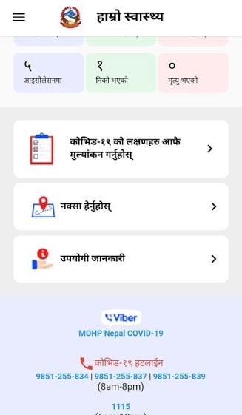

Figure 1 Hamro swasthya

Hamro Swasthya is a mobile application developed by Ministry of Health and Population, Government of Nepal. It is currently designed to help people of Nepal on the status of COVID-19 and spread awareness. Although the application has helped many people during its initial launch, many reports on bugs and complex UI has been reported by the users. Nevertheless the application has been an useful asset during the pandemic

# 

## 2.2 My Earthquake Alerts:

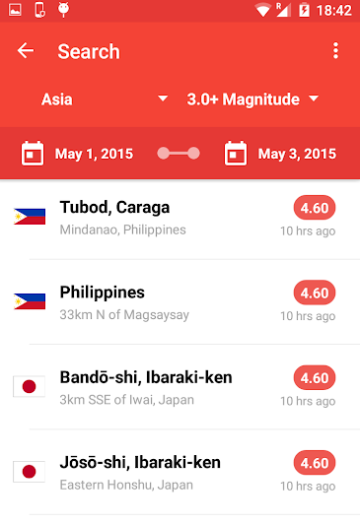

Figure 2 My Earthquake alerts

It is a widely popular earthquake monitoring application, that alerts its users whenever there is report on an earthquake. It searches for the area around your location and sorts out the closest reports of earthquake that the user should be alerted about.

## 2.3 Citizen:

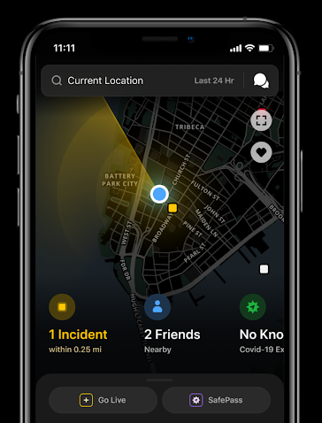

Figure 3 Citizen app

One of the most effective application, Citizen is a crime detecting application that alerts its user about the crimes reported around their area. It interacts with the police database and gives the list of history or reports the latest crime near your area. Feature of able to see other friends on the app near the crime scenes allows the user to see the threat their friends or family are in.

All these application has been an inspiration on developing “COVID Update” and has given us with good information on how “COVID Update” should look like. The frustration with Hamro Swasthya from their feedbacks has gave us clear reason to make a nice, simple UI for the users.

# Chapter 3: Design and Implementation

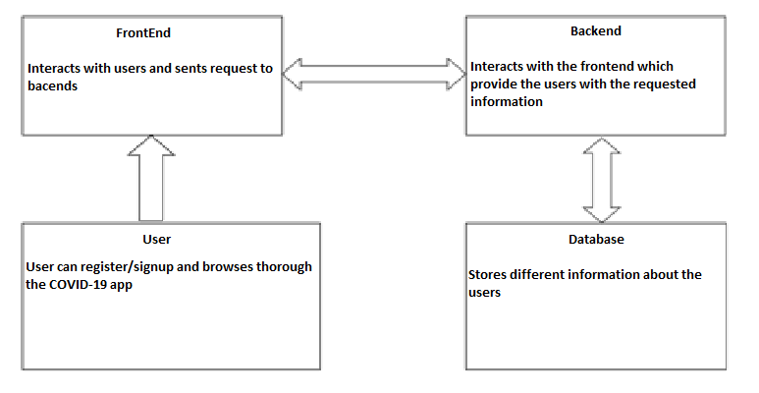

Figure 4 Work-Flow diagram

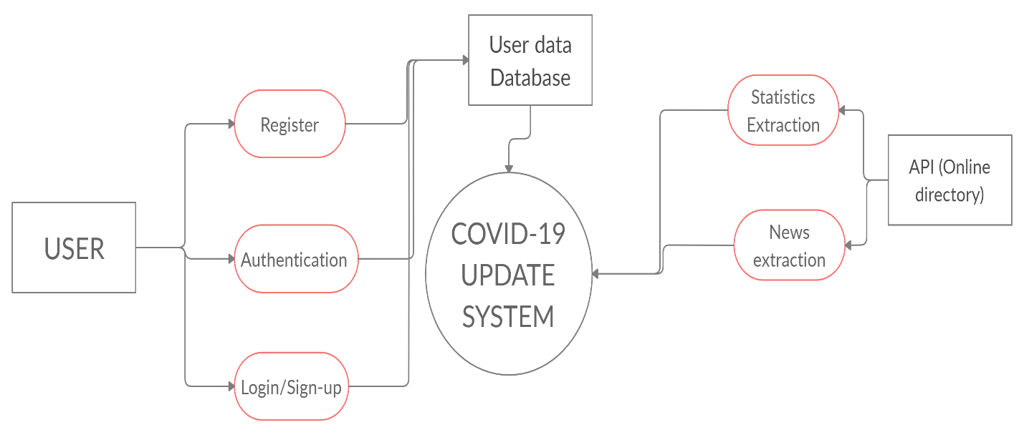

Figure 5 Data-Flow Diagram

# 3.1 System Requirement Specification

## 3.1.1 Software Specification

**3.1.1.1 Front end Tools:**

Flutter has inbuilt design material that can be used on developing the application for mobile. Many Foundation library written in Dart provides basic classes and Functions that are used in constructing a flutter application. More specifically the Material Design widgets are the leading factor for proving the libraries for developing the UI.

### 3.1.1.2 Back end Tools:

For the backend, the application is supported by DART as the programming language which is an object-oriented programming language. For the database of the application, we used Google’s Firebase.

### 3.1.1.3 RESTful API:

RESTful API is an architectural style in an application which uses HTTP requests to GET, PUT, DELETE, and POST datatypes. We had extensively used RESTful API for fetching data from the official about the COVID-19. We have also used a RESTful API in the Register System where the user can POST their email and password and then subsequently GET their email and password to be verified for the login.

## 3.1.2 Hardware Specification

Most of the current smart phone users can easy use it on their smart phone and does not consume much resource. It needs around 512MB RAM, with 1.2 GHz processing power and around 30MBs space on your memory device.

# Chapter 4: Discussion on the Achievements

## 4.1 Challenges Faced

Flutter App Development: Flutter is a new tool that is being popular and it was a new experience. Developing though Dart was new and we had to learn all it’s functions. Debugging took time as had little understanding on the tools.

Survey was a difficult part, as we did not know how to approach it and there were many bugs in the process. At the end, we developed an interactive-friendly chat system that would ask and gives suitable options to communicate with it.

## 4.2 Features

### Login System:

User can create an account

User can use that account to go to the home-screen

User has option to recover his account

### Main Features:

User can view the world data and data of any specific country

User can take the survey to check their health in any time

User can see the latest news regarding the COVID-19 in Nepal

# Chapter 5: Conclusion and Recommendation

With the use of Flutter and it’s dependencies and libraries such as firebase_auth, material, Cupertino etc we were able to develop a useful application that would a very beneficial for the general public. Although our project is small and managed to develop an important application that could be very important in present context. As the Covid-19 cases increase exponentially on a daily basis the option to check the stats as well as the symptoms of this pandemic can be really usefull.

## 5.1 Limitations

* We could have added GPS location tracker to track the user of the nearest COVID-19 victim around him.
* We wanted to make it possible to see other users of the app.
* We wanted to add user details to create a profile

## 5.2 Future Enhancements

* In future we wanted to make the UI more aesthetic and easy to use. We wanted to add the user profile options and able to use GPS to give the user

# References

1. <https://flutter.dev/docs/>
2. <https://stackoverflow.com/questions/tagged/flutter>
3. <https://codelabs.developers.google.com/?cat=Flutter>
4. Ed Freitas, "Flutter Succinctly" [ebook] Available at: <<https://www.syncfusion.com/ebooks/flutter-succinctly>>
5. Maximmilian Schwarzmuller, "Flutter & Dart - The Complete Guide [2020 Edition]" [online] Available: <<https://www.udemy.com/course/learn-flutter-dart-to-build-ios-android-apps/>>

# Appendix

|  |  |  |  |  |  |  |  |  |  |  |  |
| --- | --- | --- | --- | --- | --- | --- | --- | --- | --- | --- | --- |
| **Task** | 1 | 2 | 3 | 4 | 5 | 6 | 7 | 8 | 9 | 10 | 11 |
| Research and study |  |  |  |  |  |  |  |  |  |  |  |
| Graphic Designing |  |  |  |  |  |  |  |  |  |  |  |
| Core Programming |  |  |  |  |  |  |  |  |  |  |  |
| Program testing |  |  |  |  |  |  |  |  |  |  |  |
| Documentation |  |  |  |  |  |  |  |  |  |  |  |

**Table 5.1: Gantt Chart**

**Tasks**:

1. Research and Study
2. Graphic Designing
3. Core Programming
4. Program Testing
5. Documentation

# Screen-Shots

